1. [20 points] Discuss/explain what is meant by the term ventilation/perfusion matching. Describe/discuss/explain the local mechanism(s) that control ventilation/perfusion matching.

Ventilation/perfusion matching is the balance between ventilation and perfusion. To be most efficient, the correct proportion of alveolar airflow (ventilation) and capillary blood flow (perfusion) should be available to each alveolus, ideally for each molecule of gas which jumps into the blood, we would have a molecule in the capillary blood flow taking it away, a 1-1 matching. In normal lung, the overall ventilation/perfusion ratio is approximatively 0.8. There are several local mechanism(s) that minimize the mismatching of ventilation and blood flow to maximize the efficiency of gas exchange: whenever there is a mismatch of ventilation and blood flow, there is going to be local adjustments at the same time of airway resistance and blood flow to reduce the mismatch.

For example, in a region with small air flow but large blood flow, there is a low local PO2, and local PCO2 will increase (↑ PCO2) because there is not enough air to carry off the CO2 brought by the blood, which leads to a decrease of the contraction of airway smooth muscle, which causes a decrease of airway resistance to try to bring in more air to the region where there is not enough air (figure 1: area 2, right side, Module 12, Video 3, slide 8).

At the same time in the pulmonary blood vessel, local PO2 will decrease (↓ PO2) since there is not enough ventilation to match the amount of blood and the blood cannot be load up with O2. As a result, there is an increase of contraction of the pulmonary vessel smooth muscles (vasoconstriction), which causes an increase of vascular resistance in order to reduce the blood flow (figure 1: area 2, right side, Module 12, Video 3, slide 9): therefore, there is a local drop in perfusion to match the initial drop in ventilation. Following this drop in perfusion, the blood will be redirected to alveoli that are well ventilated.

Similarly, a drop in perfusion, like for example a clot in blood vessel surrounded by alveoli, results in local opposite effects of the ones just described: a local decrease in blood flow brings less local systemic CO2 to that area, resulting in a local decrease in PCO2. This causes bronchoconstriction, which diverts airflow away to areas of the lung with better perfusion (figure 1: area 1, left side, Module 12, Video 3, slide 8 and 9).

These local mechanisms happen to have a better ventilation/perfusion match so the body is not wasting ventilation on regions not well perfused or wasting perfusion on regions not well ventilated.

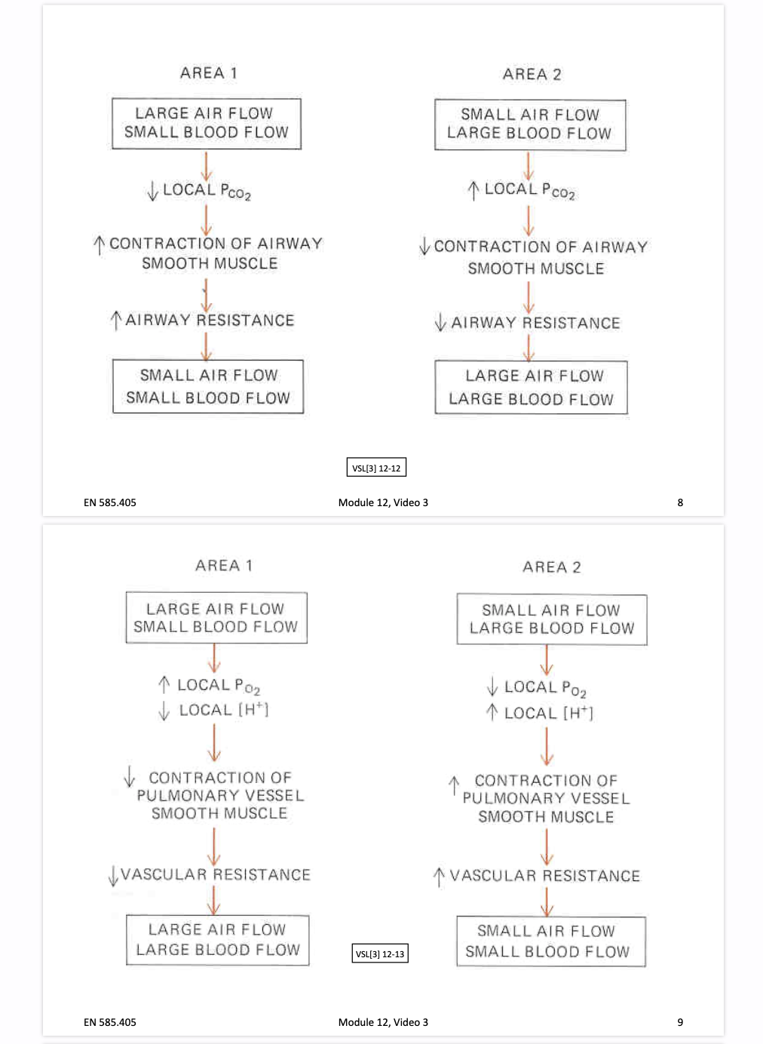

**Fig.1: Module 12, Video 3, Slide 8 and 9**

1. [20 points] Distinguish between the terms anatomic dead space and physiologic dead space.

The total volume of gas in each breath that does not participate in gas exchange is called the physiologic dead space. It is qualified as “dead” because it is wasted ventilation and corresponds to air that is inspired but does not participate in gas exchange. This volume of air includes the anatomic dead space and the dead space secondary to perfused but unventilated alveoli:

Physiologic = anatomic + alveolar dead space (Module 12, Video 1, Slide 8)

* *Anatomic dead space* (nose, pharynx, larynx, trachea, bronchi, bronchioles, non-respiratory bronchioles) refers to the conducting airways. The conducting airways contain no alveoli and therefore do not participate in gas exchange (for a person of 150 pounds, volume of the anatomic dead space is about 150 ml).
* *Alveolar dead space*: inspired air reaches alveoli that are not perfused or poorly perfused (their capillaries do not get blood or they have thickened walls due to some disease) so these alveoli do not take part in gas exchange. Alveolar dead space typically is negligible in a healthy individual.

The physiologic dead space is always at least as large as the anatomic dead space, and in the presence of disease, it may be considerably larger.

1. [20 points] Differentiate between the terms pulmonary minute ventilation and alveolar minute ventilation.

Ventilation is the process by which air moves in and out of the lungs. The incoming air is composed of a volume that fills the conducting airways (dead space ventilation) and a portion that fills the alveoli (alveolar ventilation): VT = VD + VA where VT refers to tidal volume, VD anatomic dead space volume and VA alveolar volume.

From this equality we determine three main types of ventilation rates:

* Pulmonary minute ventilation: = VT x f. The amount of air that enters of leaves the lungs per minute. f is the number of breaths per minute: a “dot” above V denotes a volume per unit of time (if f is used then it is volume per minute)
* Anatomic dead space ventilation (anatomic dead space minute ventilation): the amount of air per minute that is not involved in gas exchange, such as the air that remains in the conducting airways (see previous question):    = VD x f
* Alveolar minute ventilation: the amount of gas per minute that reaches the alveoli and becomes involved in gas exchange:

= VA x f = VT x f – VD x f = -

For example, at rest, a typical healthy adult moves approximately 500 mL of air in and out of the lungs with each breath and takes 12 breaths a minute. The pulmonary minute ventilation is: = 500 mL/breaths x 12 breath/minute = 6000 mL of air/minute. For an anatomical dead space of 150mL (VD), of a 500 mL tidal volume breath, the first 150 mL entering the alveoli is not “fresh” air but the 150 mL left behind in the airways from the last breath. Only approximately 350 mL of new atmospheric air enters the alveoli during inspiration which is the alveolar volume. The alveolar minute ventilation is:

= (500 – 150) x 12 = 350 x 12 = 4200 mL/minute.

However alveolar ventilation rather pulmonary minute ventilation is the important factor characterizing the effectiveness of gas exchange. Consider the table below, three subjects A, B and C. They all have the same minute ventilation, yet when we subtract the anatomic dead space ventilation from the minute ventilation which gives us the alveolar minute ventilation, we see striking differences: subject A has no alveolar ventilation and would quickly become unconscious, whereas C has a greater alveolar ventilation than C, C compared to B breathes more slowly and deeply.

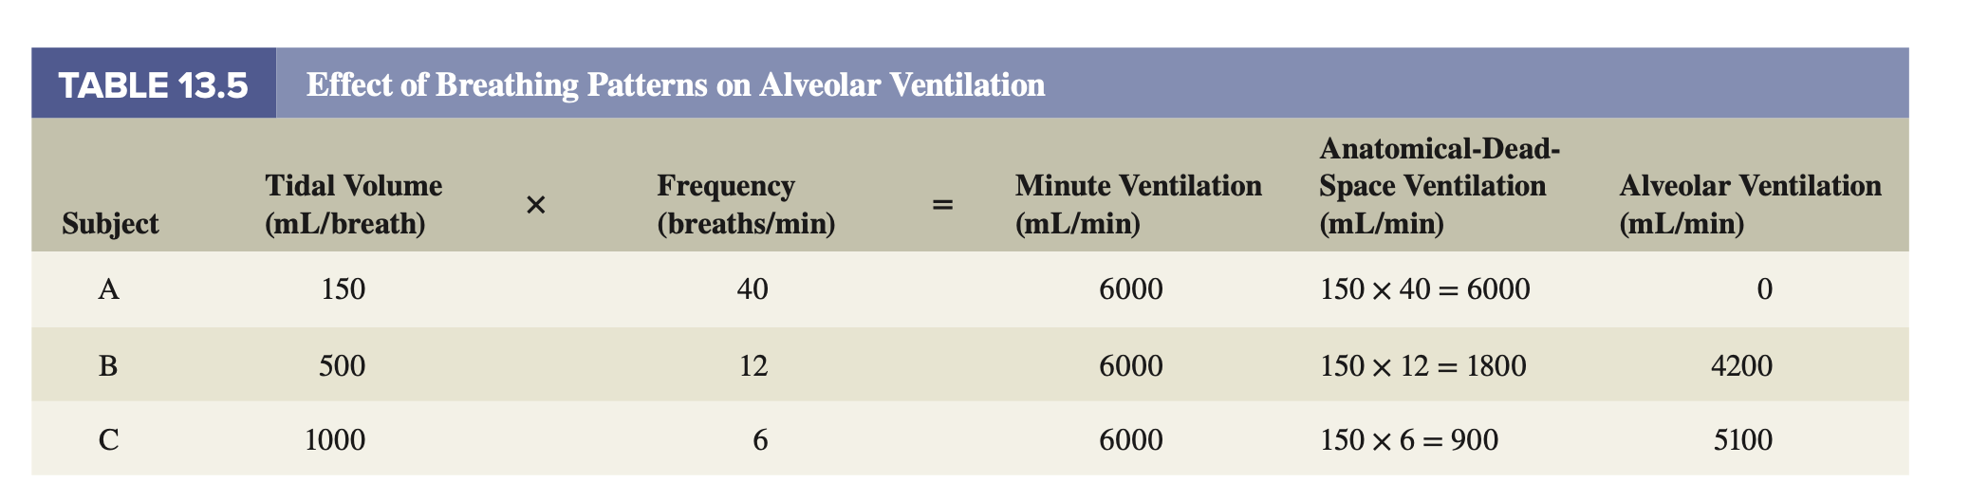

**Table 13.5 VSL[15] p.460**